**ScreenShots Of Workshop Management system**

**Home Screen**

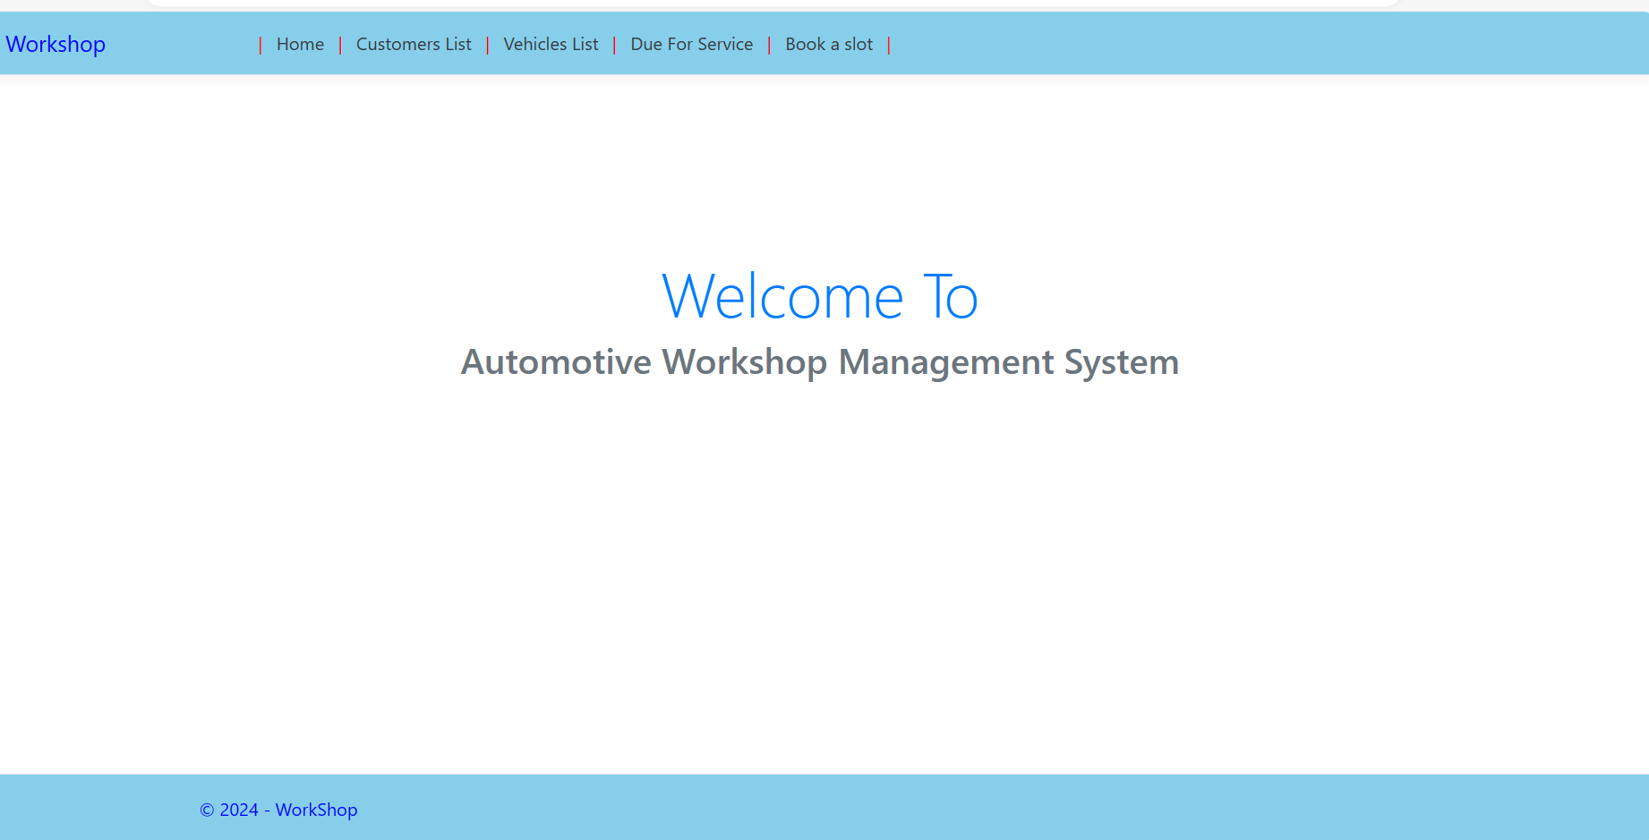

**list of customer**

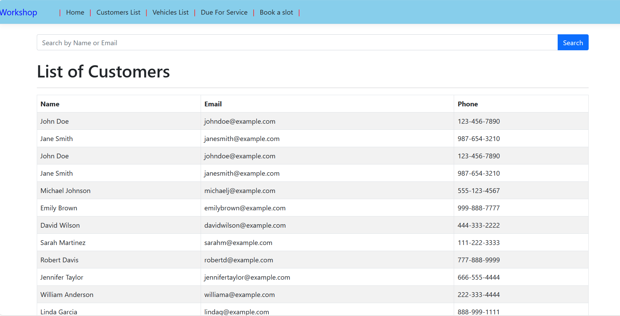

**3.) list of customer by name**

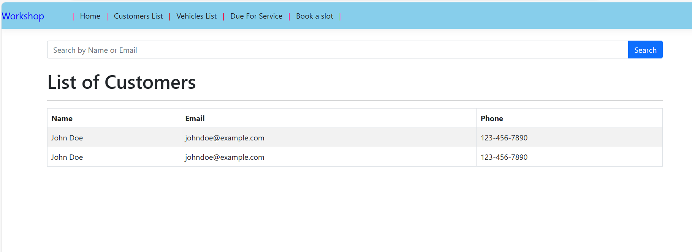

**4.) list of vehicles by customer name**

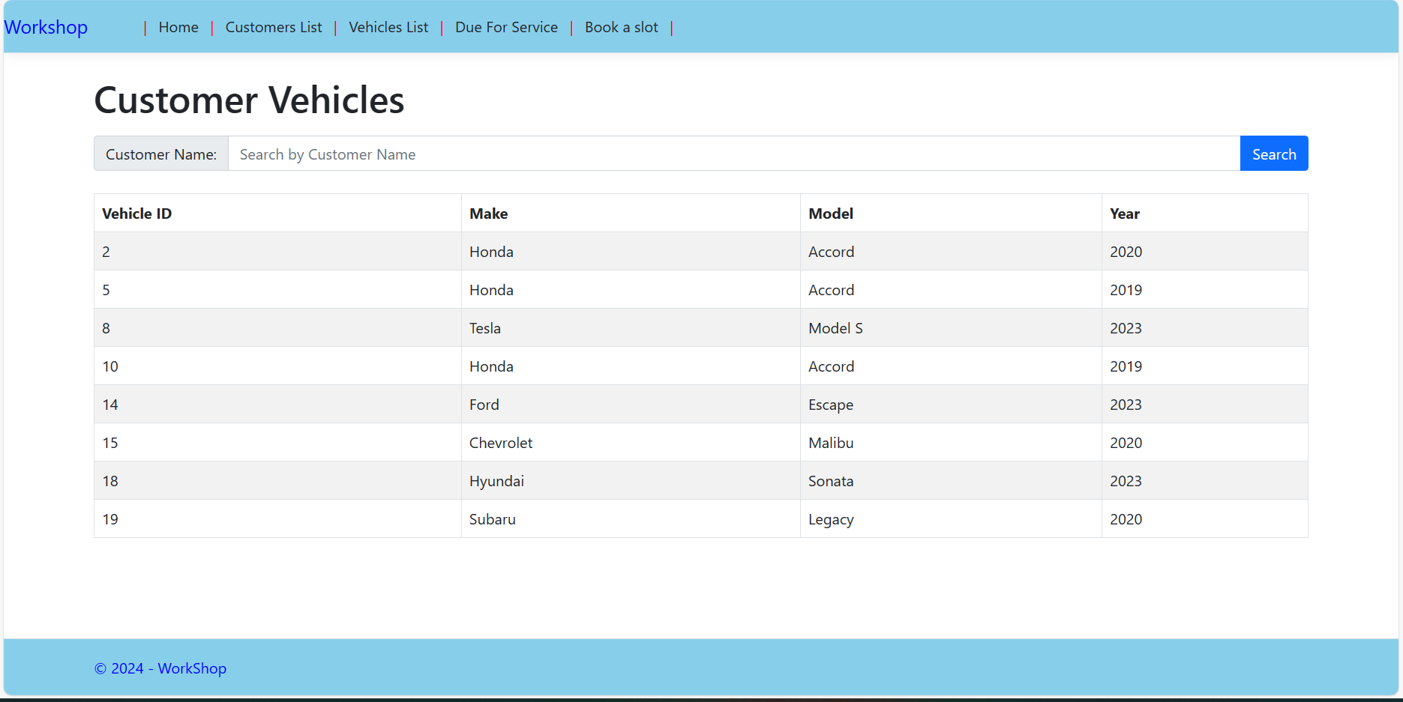

**5.) vehicles due for services sorted by due date**

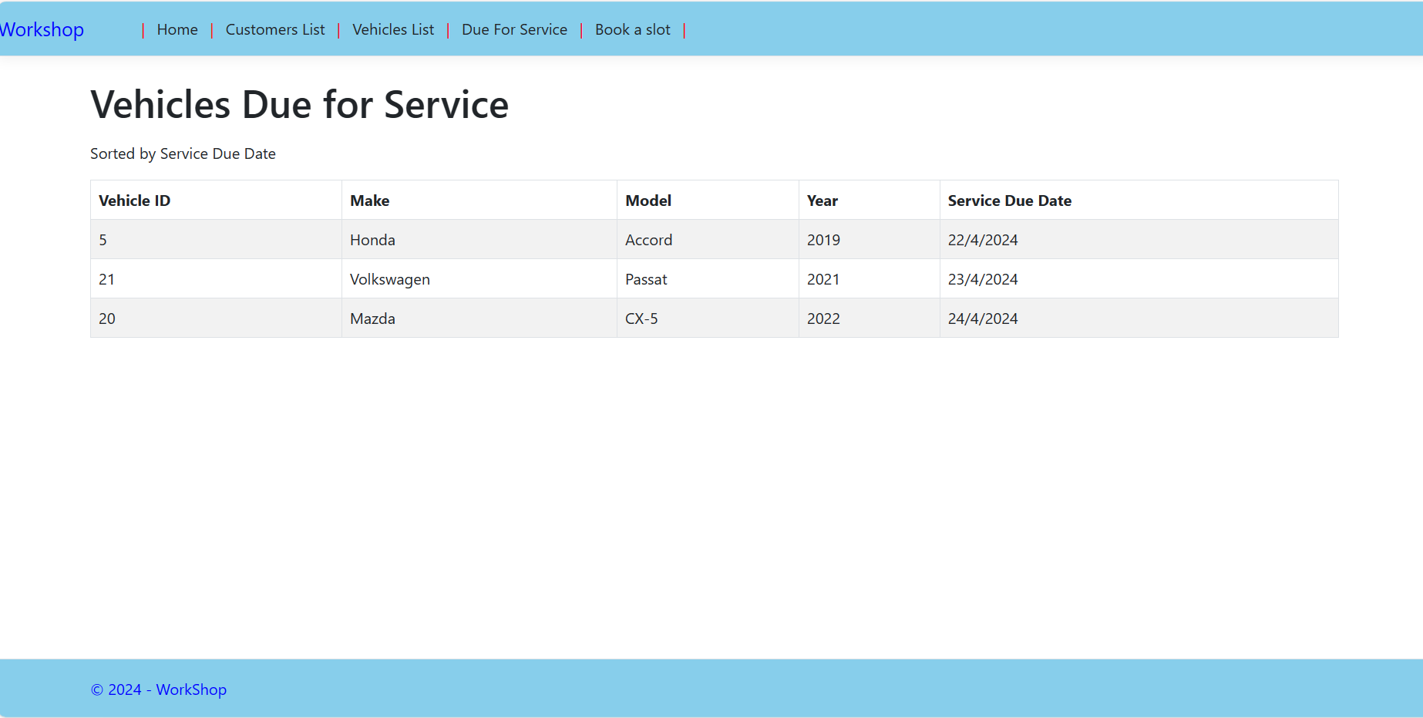

**6.) book a slot**

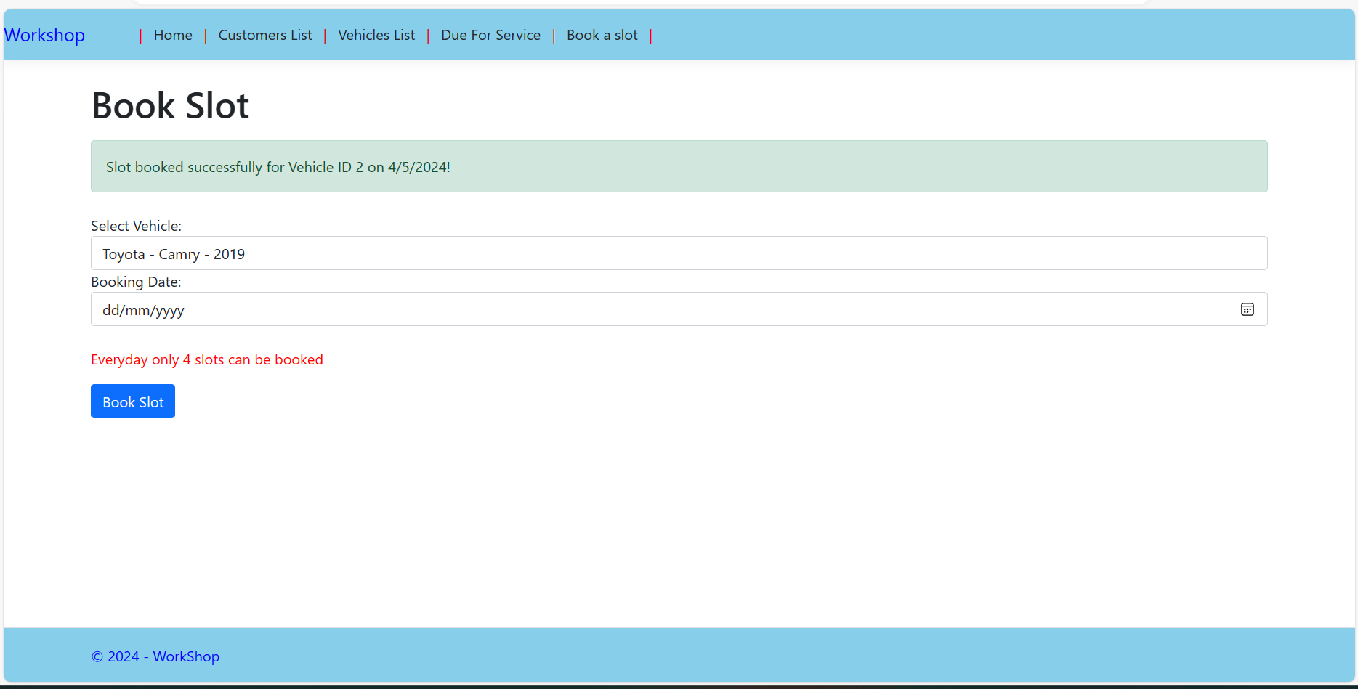

**7.) after 4 booking per day booking will be failed**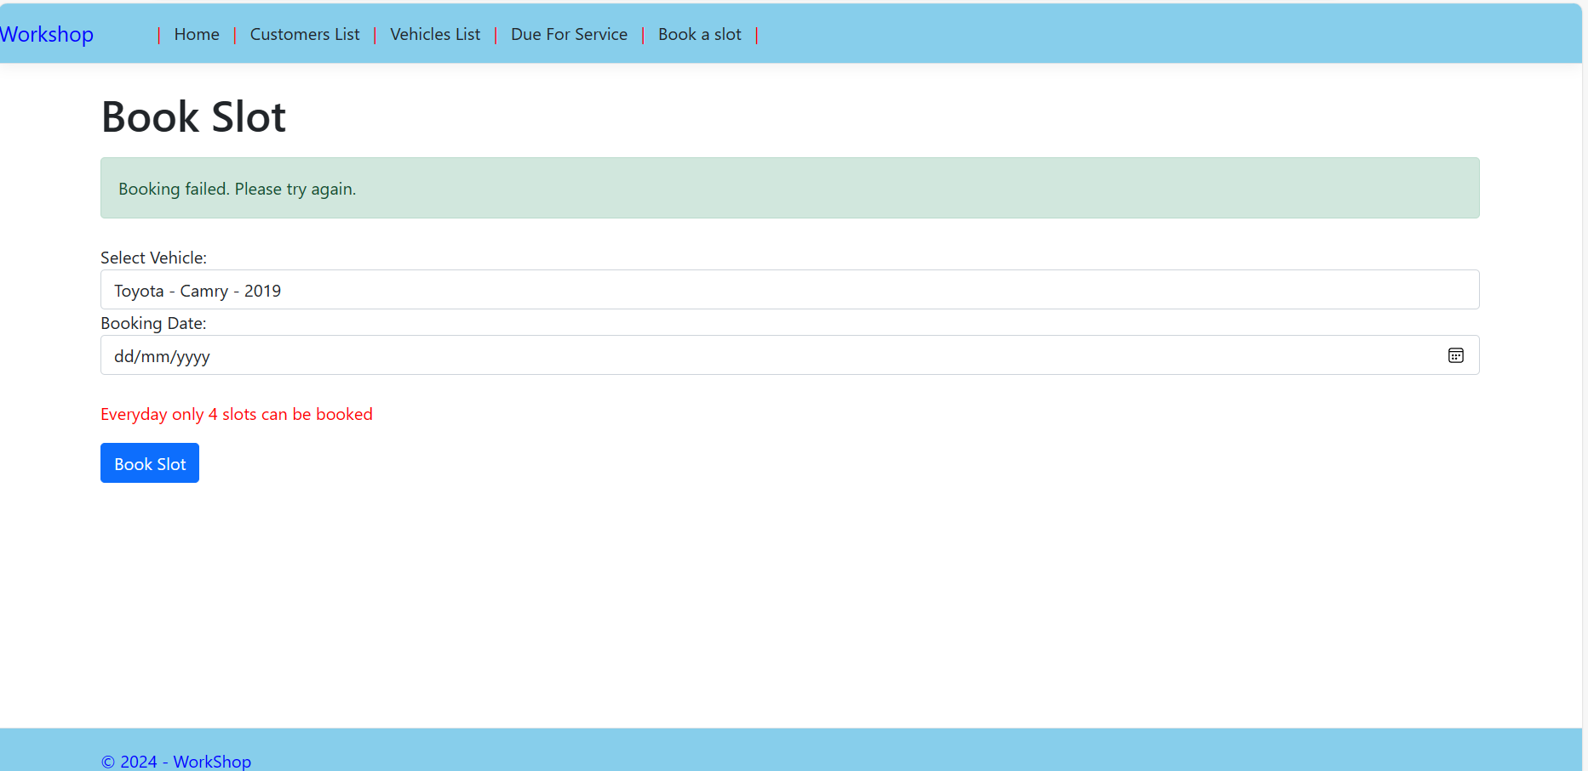

**8.) Replace your connection string with existing one in AppSetting.json**

